Phase 5 Apex Programming
- Trigger & Handler – Prevent Duplicate Active Loans
• Prevents creating/updating multiple active loans for the same customer.
• Bulk-safe; handles multiple loan applications at once.
Trigger (LoanApplicationTrigger.trigger)
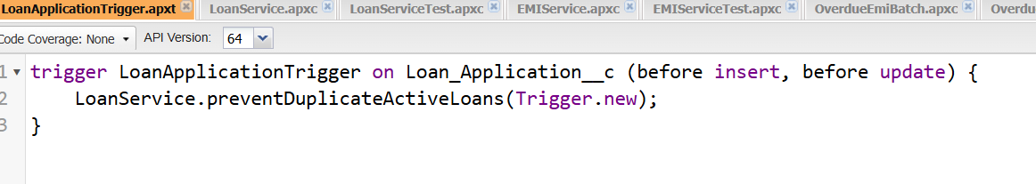 Handler (LoanApplicationHandler.cls)
Prevents creating/updating multiple active loans for the same customer.
Bulk-safe; handles multiple loan applications at once.
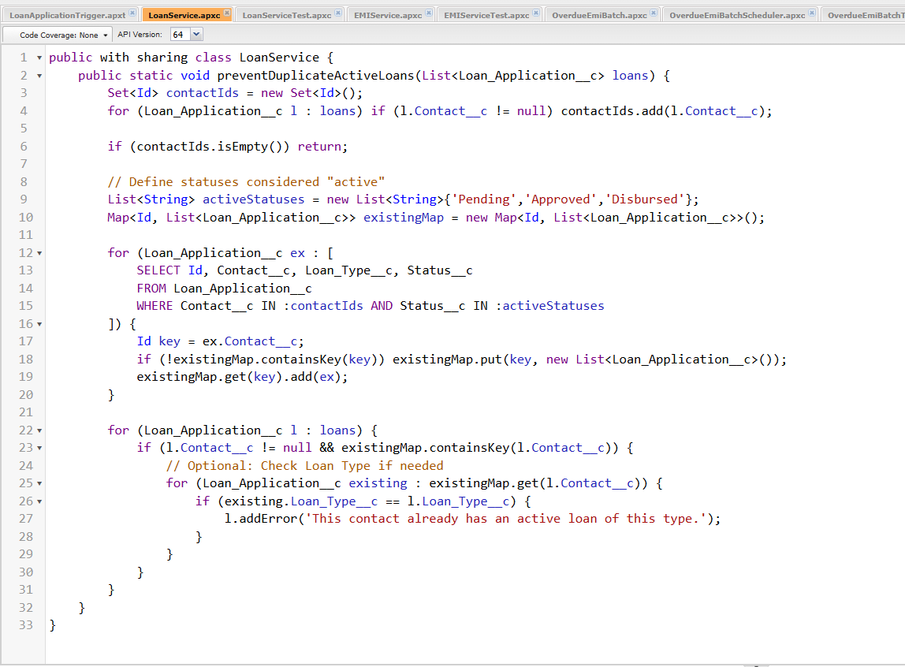

Output:
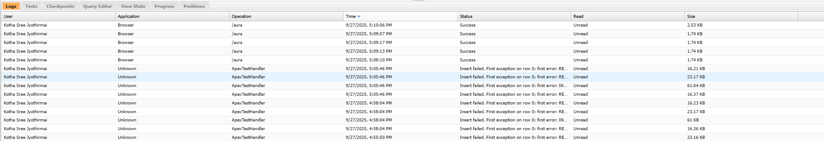
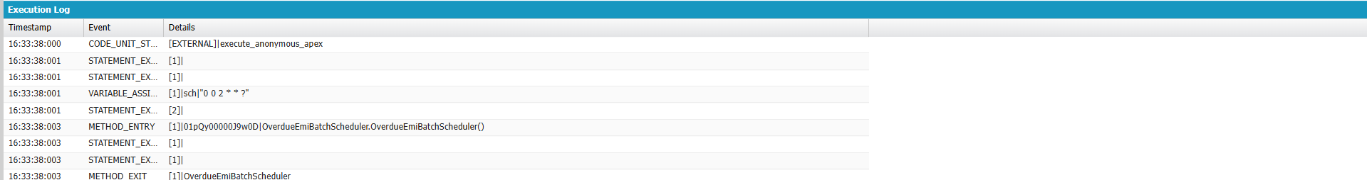
- EMI Generation Service
• Generates amortized EMI schedules for approved loans.
• Can be invoked via Flow or directly in Apex.
EMIService.cls
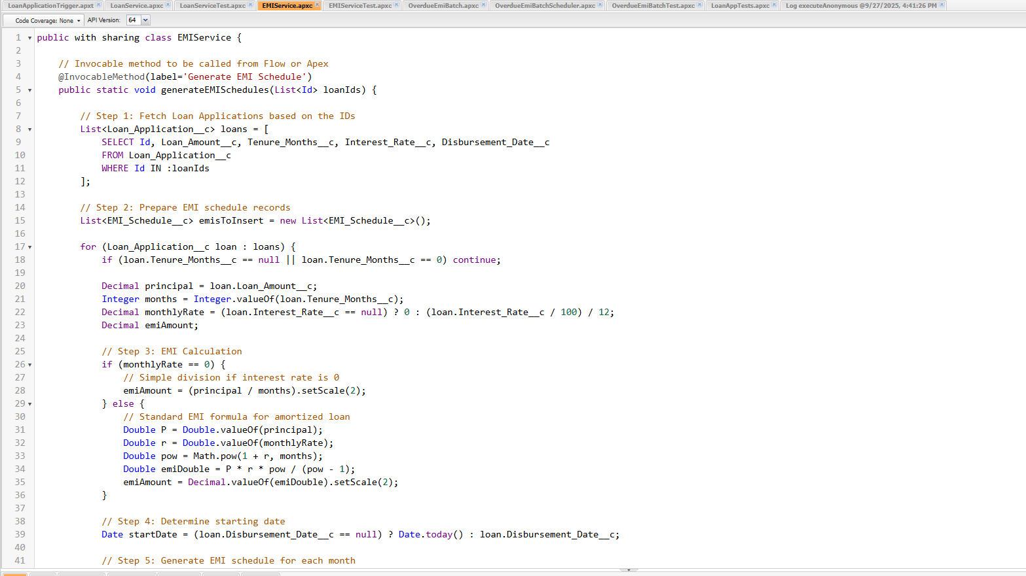

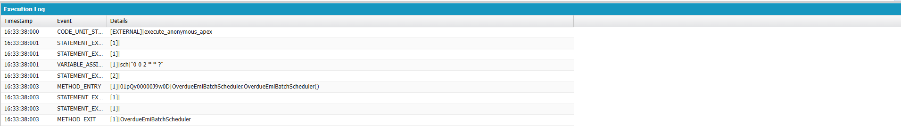

EMIServiceTest.cls
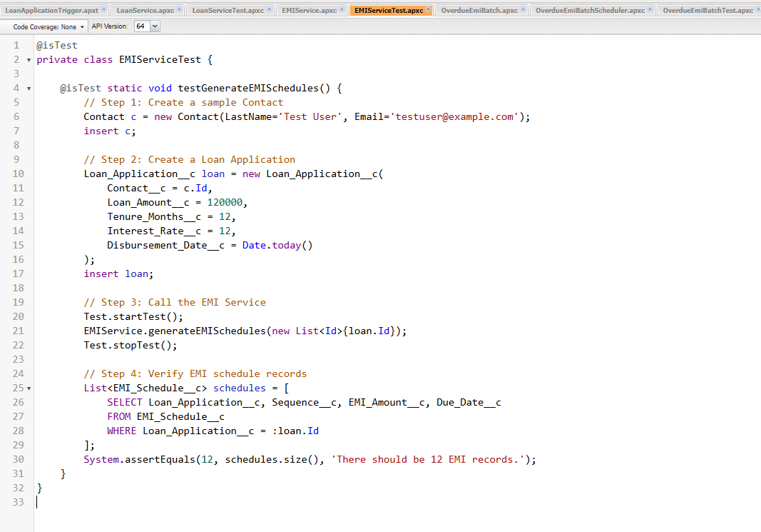
Output:
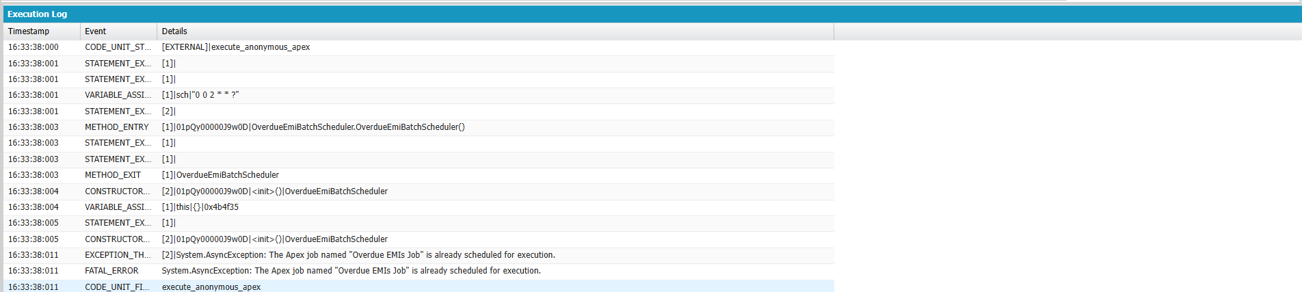
c) Overdue Batch – Scheduled Nightly
- Automatically marks EMIs overdue nightly.
- Bulk-safe and efficient.
OverdueEmiBatch.cls
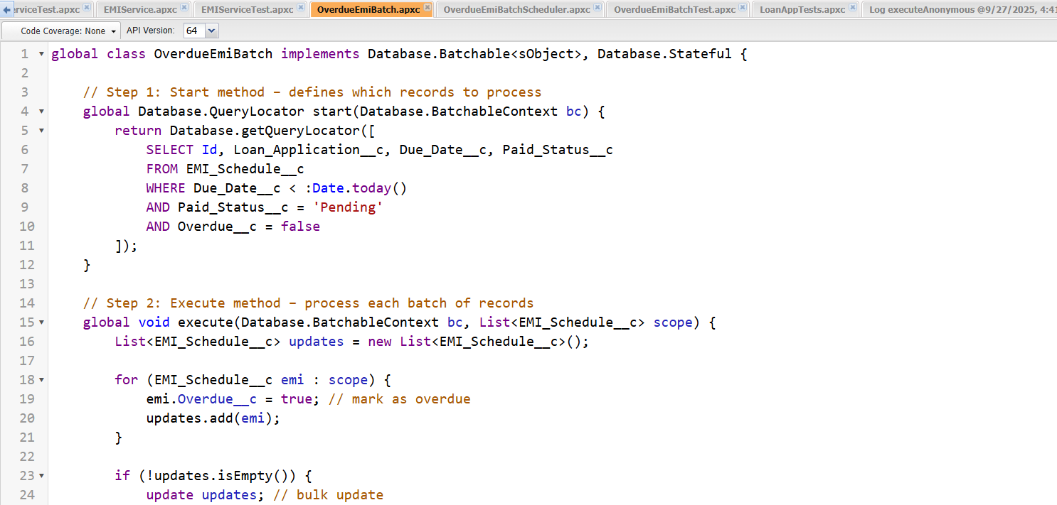
Scheduler.cls
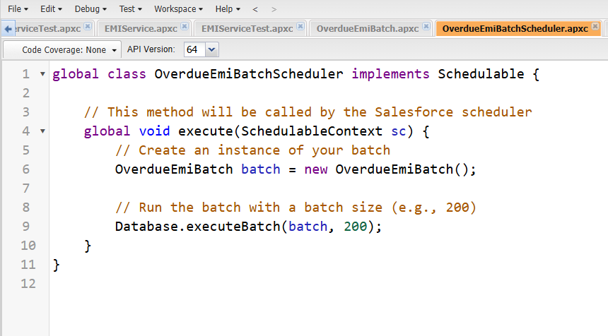
Test class
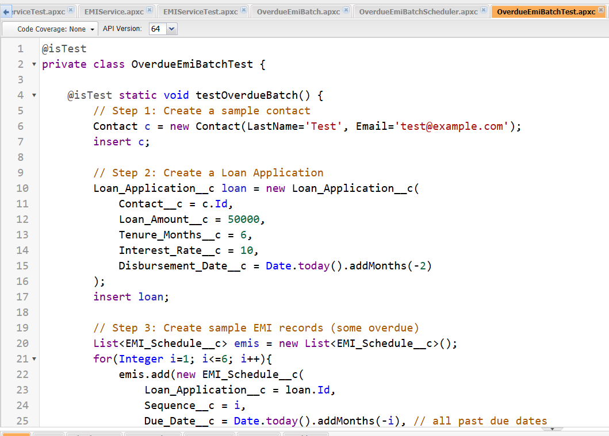
Output
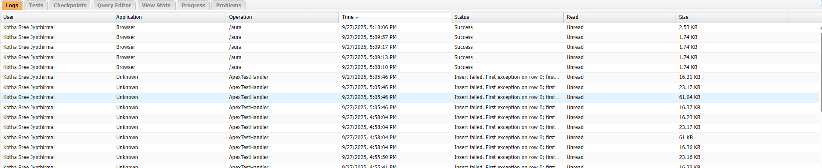

Test Classes
- Covers duplicate loan prevention.
- Verifies correct EMI generation.
- Ensures bulk-safe operations.
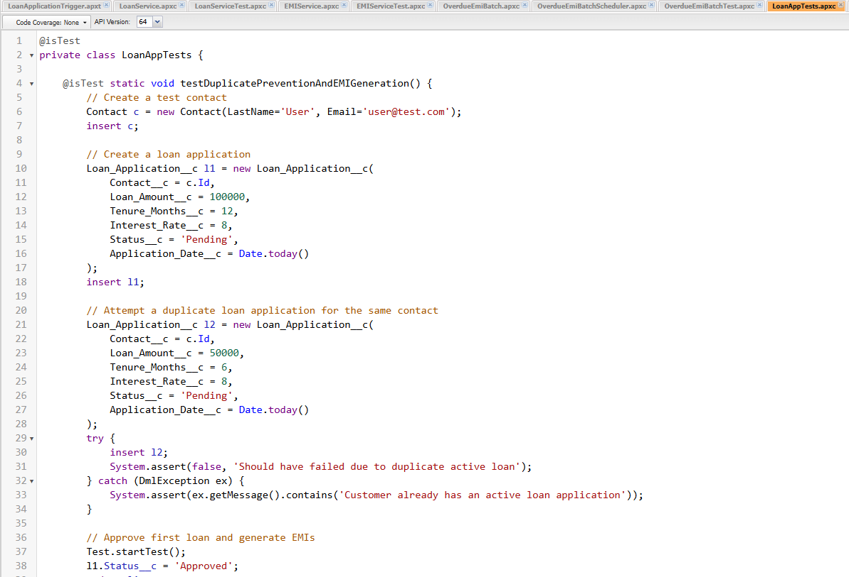
Output:
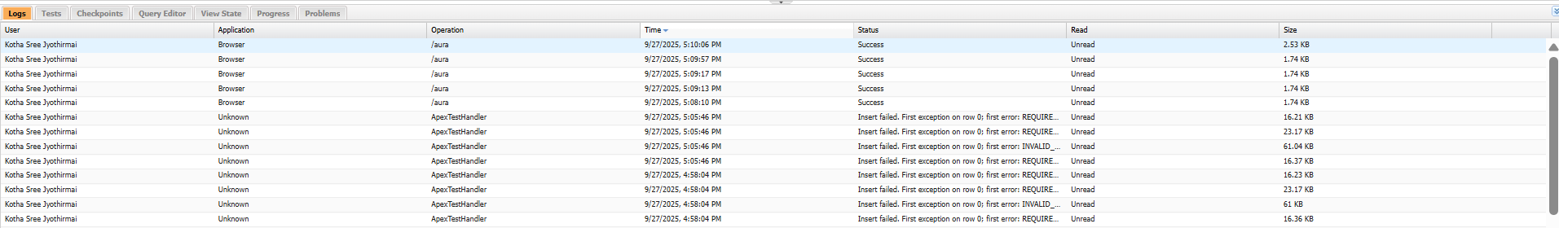

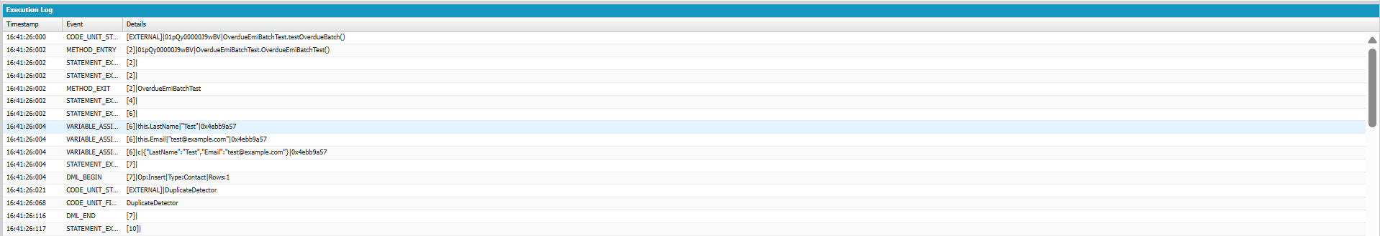

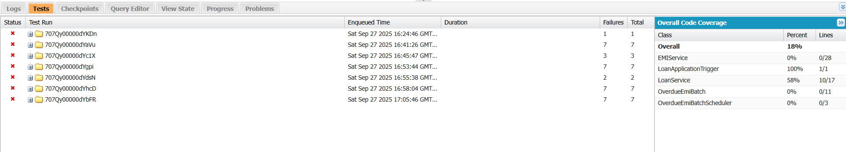
Collections:
In Apex, collections are lists, sets, and maps. In this test class, you’re using:
List<Id>
EMIService.generateEMISchedules(new List<Id>{l1.Id});
- A List collection is created with a single Loan Id (l1.Id).
- Passed to EMIService so it can bulk-generate EMI schedules for one or more loans.
- Shows bulkification best practice.

Control Statements Used
Control statements control flow of logic in your code. In this test class, you’re using:
1. try-catch block
try {
insert l2;
System.assert(false, 'Should have failed due to duplicate active loan');
} catch (DmlException ex) {
System.assert(ex.getMessage().contains('Customer already has an active loan application'));
}
- Purpose: Handle the expected DML exception.
- try → attempts to insert a duplicate loan.
- catch → catches the DmlException when trigger blocks it.
- Ensures negative testing is validated.

